EASTERN INTERNATIONAL UNIVERSITY Practice Assignment – Quarter 4, 2023-2024
SCHOOL OF COMPUTING Course Name: Database
AND INFORMATION TECHNOLOGY Course Code: CSE 301
Student’s Full Name: Nguyễn Khắc Duy
Lab 3

Student ID: 2131220021

Using MySQL Workbench to create Database, Table, Statements related Database.

Problem 1: Sale management Database
- Create the following tables in a new database ‘SaleManagement’:
- Create a new database with the name " SaleManagement".
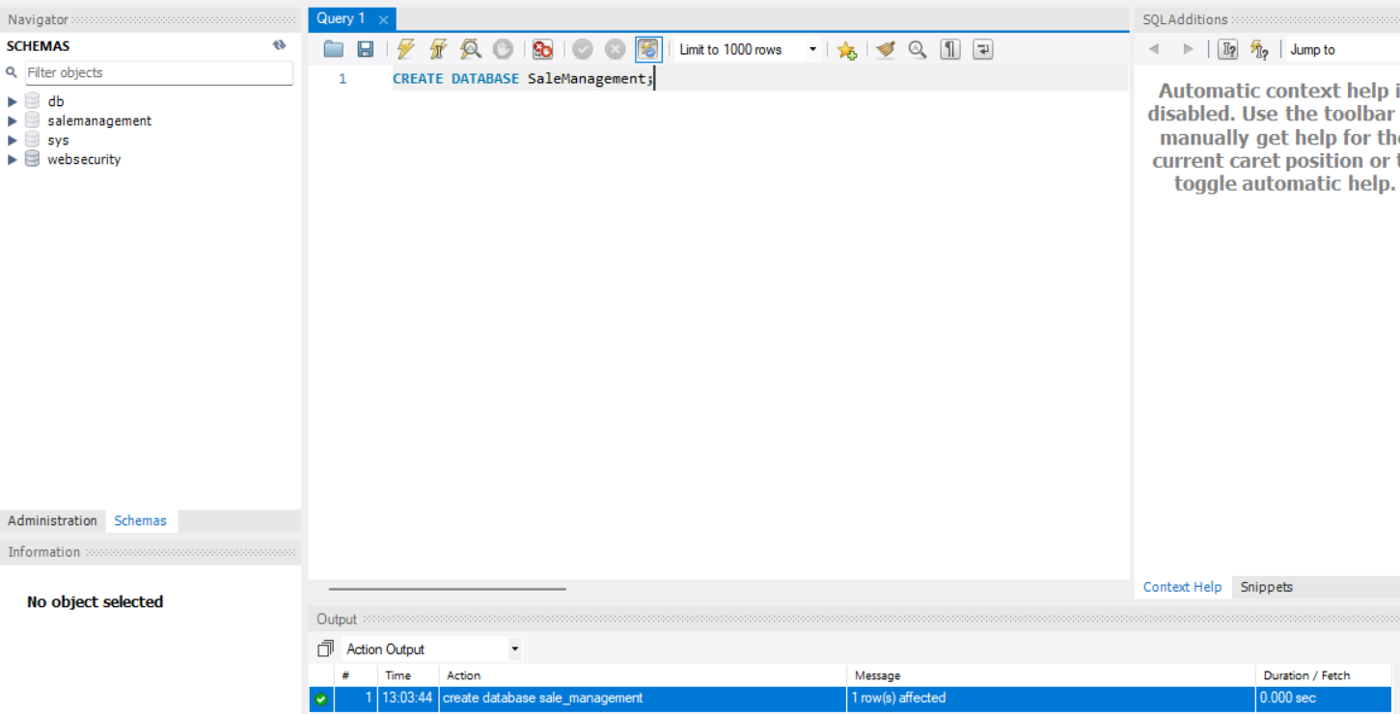
- Create all the tables under this database.
- Informations Tables:
- Table Name: Clients
Column Name | Data Type | Size | Constraints | 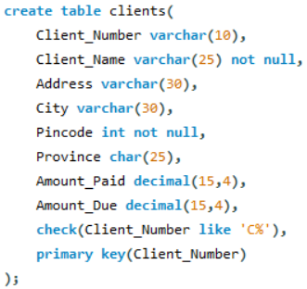
Client_Number | VARCHAR | 10 | Primary Key, first letter must start with ‘C’
Client_Name | VARCHAR | 25 | Not null
Address | VARCHAR | 30
City | VARCHAR | 30
Pincode | INT |  | Not null
Province | CHAR | 25
Amount_Paid | DECIMAL | 15,4
Amount _Due | DECIMAL | 15,4
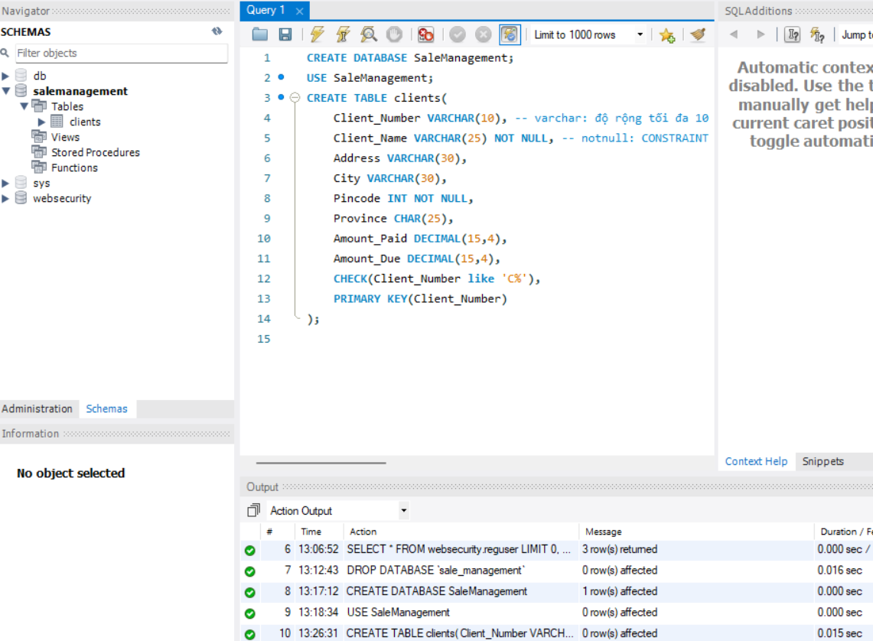
- Table Name: Product
Column Name | Data Type | Size | Constraints | 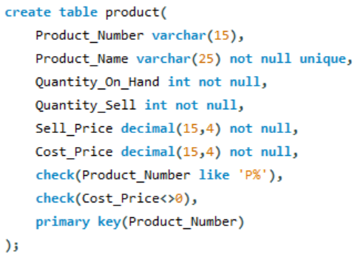
Product_Number | VARCHAR | 15 | Primary Key, first letter must start with ‘P’
Product_Name | VARCHAR | 25 | Not null, Unique
Quantity_On_Hand | INT |  | Not null
Quantity_Sale | INT |  | Not null
Sale_Price | DECIMAL | 15,4 | Not null
Cost_Price | DECIMAL | 15,4 | Not null, cannot be 0

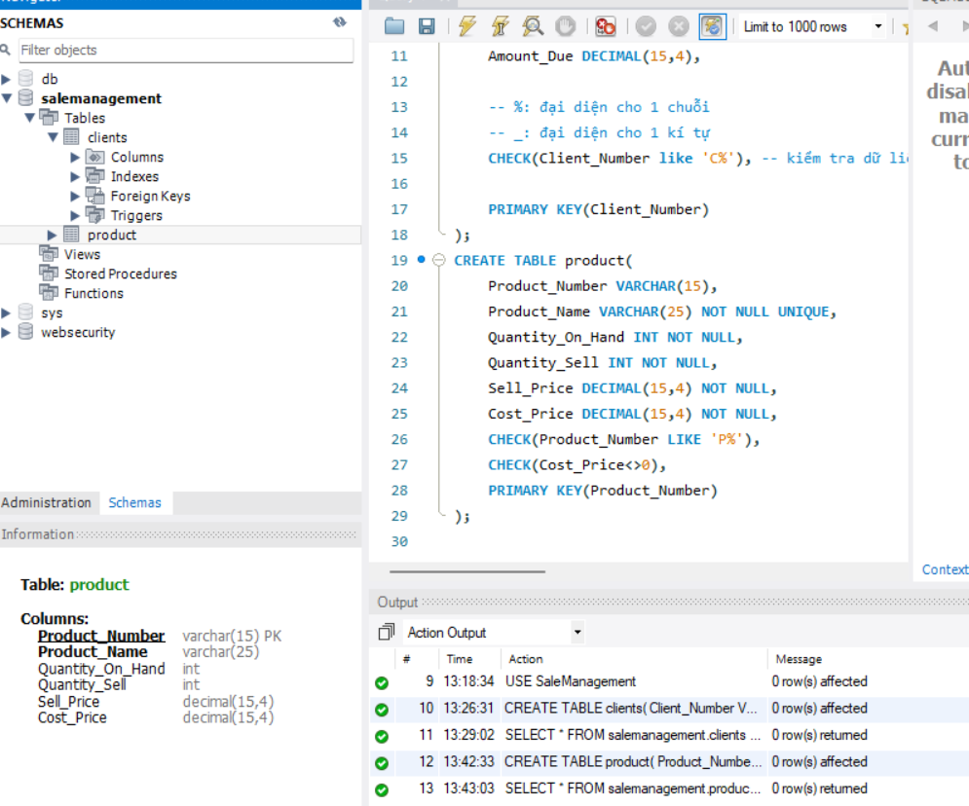

- Table Name: Salesman
Column Name | Data Type | Size | Constraints | 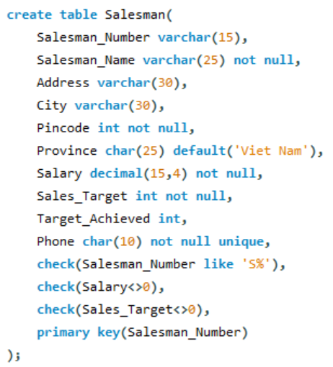
Salesman _Number | VARCHAR | 15 | Primary Key, first letter must start with ‘S’
Salesman _Name | VARCHAR | 25 | Not null
Address | VARCHAR | 30
City | VARCHAR | 30
Pincode | INT |  | Not null
Province | CHAR | 25 | Default ‘Vietnam’
Salary | DECIMAL | 15,4 | Not null, cannot be 0
Sales_Target | INT |  | Not null, cannot be 0
Target_Achieved | INT
Phone | CHAR | 10 | Not null, Unique,

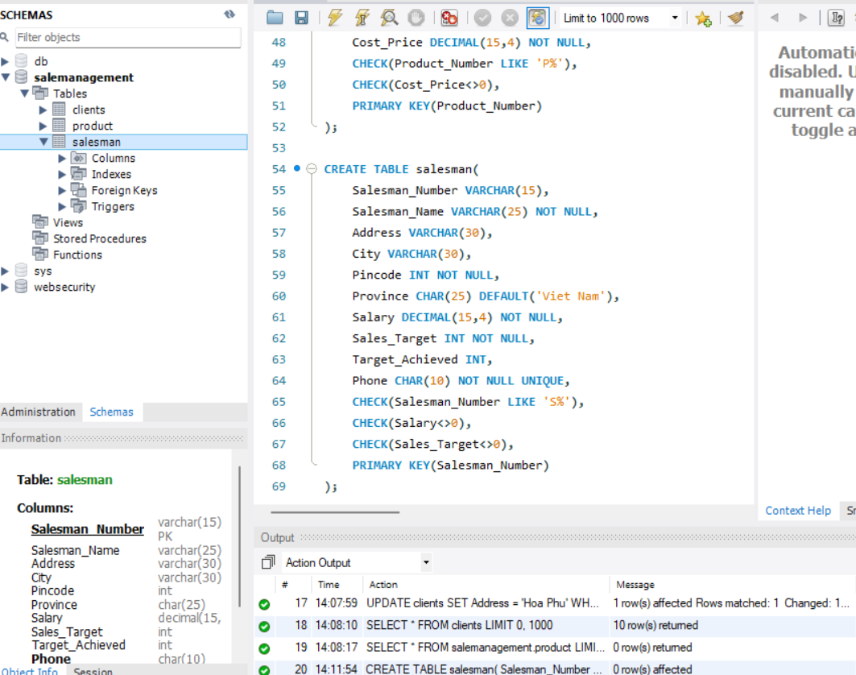
- Table Name: SalesOrder
Column Name | Data Type | Size | Constraints
Order_Number | VARCHAR | 15 | Primary Key, first letter must start with ‘O’
Order_Date | DATE
Client_Number | VARCHAR | 10 | Foreign key references Client_Number of Client table, first letter must start with ‘C’
Salesman_Number | VARCHAR | 15 | Foreign key references Salesman_Number of Salesman table, first letter must start with ‘S’
Delivery_Status | CHAR | 15 | Values (‘Delivered’, ‘On Way’, ‘Ready to Ship’)
Delivery_Date | DATE |  | Cannot be less than Order_date
Order_Status | VARCHAR | 15 | Values (‘In Process’, ‘Successful’, ‘Cancelled’)

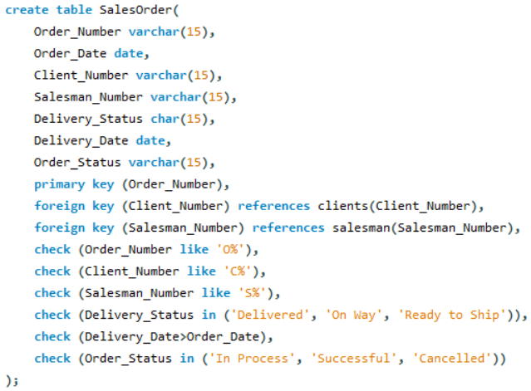
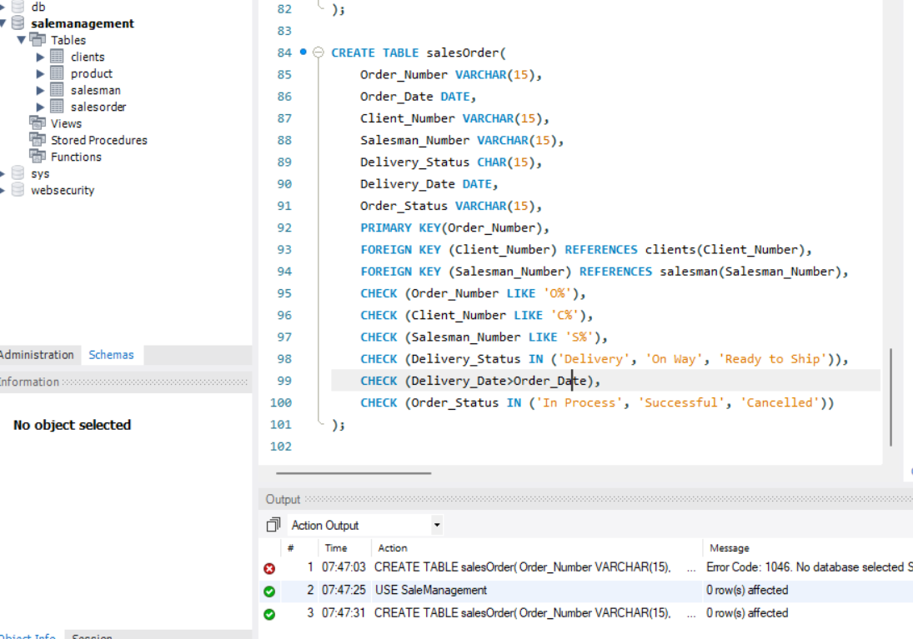
- Table Name: SalesOrderDetails
Column Name | Data Type | Size | Constraints | 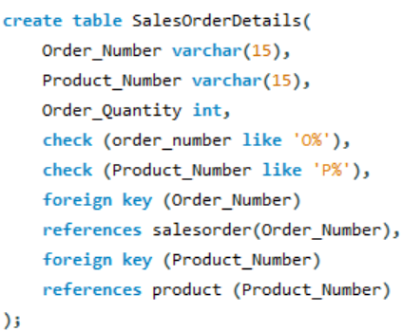
Order_Number | VARCHAR | 15 | Foreign key references Order_Number of Sales_Order table
Product_Number | VARCHAR | 15 | Foreign key references Product_Number of Product table, first letter must start with ‘P’
Order_Quantity | INT
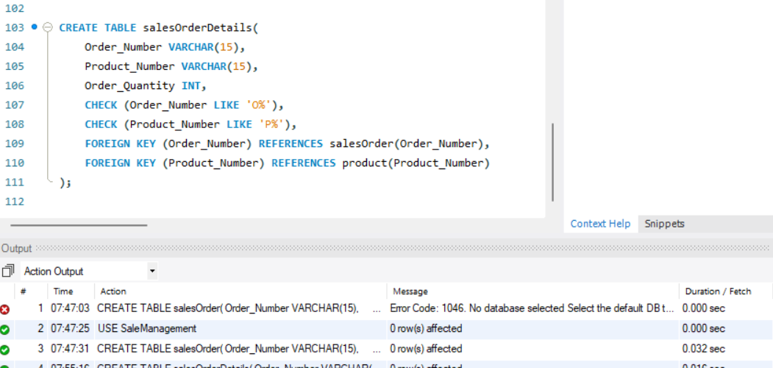
- Insert Data into following tables:
- Clients
Client_Number | Client_Name | Address | City | Pincode | Province | Amount_Paid | Amount_ Due
C101 | Mai Xuan | Phu Hoa | Dai An | 700001 | Binh Duong | 10000 | 5000
C102 | Le Xuan | Phu Hoa | Thu Dau Mot | 700051 | Binh Duong | 18000 | 3000
C103 | Trinh Huu | Phu Loi | Da Lat | 700051 | Lam Dong | 7000 | 3200
C104 | Tran Tuan | Phu Tan | Thu Dau Mot | 700080 | Binh Duong | 8000 | 0
C105 | Ho Nhu | Chanh My | Hanoi | 700005 | Hanoi | 7000 | 150
C106 | Tran Hai | Phu Hoa | Ho Chi Minh | 700002 | Ho Chi Minh | 7000 | 1300
C107 | Nguyen Thanh | Hoa Phu | Dai An | 700023 | Binh Duong | 8500 | 7500
C108 | Nguyen Sy | Tan An | Da Lat | 700032 | Lam Dong | 15000 | 1000
C109 | Duong Thanh | Phu Hoa | Ho Chi Minh | 700011 | Ho Chi Minh | 12000 | 8000
C110 | Tran Minh | Phu My | Hanoi | 700005 | Hanoi | 9000 | 1000
Script to insert data:
('C101','Mai Xuan','Phu Hoa','Dai An',700001,'Binh Duong',10000,5000),
('C102','Le Xuan','Phu Hoa','Thu Dau Mot',700051,'Binh Duong',18000,3000),
('C103','Trinh Huu','Phu Loi','Da Lat',700051,'Lam Dong ',7000,3200),
('C104','Tran Tuan','Phu Tan','Thu Dau Mot',700080,'Binh Duong',8000,0),
('C105','Ho Nhu','Chanh My','Hanoi',700005,'Hanoi',7000,150),
('C106','Tran Hai','Phu Hoa','Ho Chi Minh',700002,'Ho Chi Minh',7000,1300),
('C107','Nguyen Thanh ','Hoa Phu','Dai An',700023,'Binh Duong',8500,7500),
('C108','Nguyen Sy','Tan An','Da Lat',700032,'Lam Dong ',15000,1000),
('C109','Duong Thanh','Phu Hoa','Ho Chi Minh',700011,'Ho Chi Minh',12000,8000),
('C110','Tran Minh','Phu My','Hanoi',700005,'Hanoi',9000,1000);
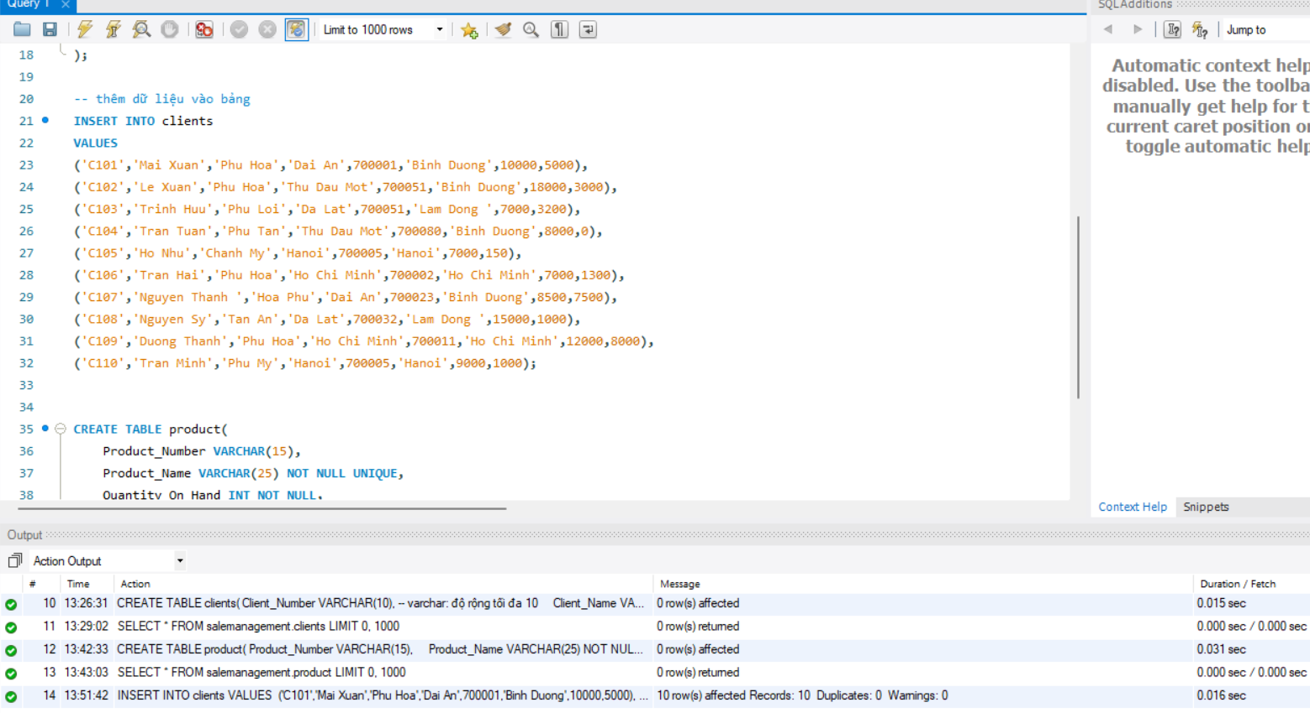

- Product
Product_Number | Product_Name | Quantity_On_Hand | Quantity_Sell | Sell_Price | Cost_Price
P1001 | TV | 10 | 30 | 1000 | 800
P1002 | Laptop | 12 | 25 | 1500 | 1100
P1003 | AC | 23 | 10 | 400 | 300
P1004 | Modem | 22 | 16 | 250 | 230
P1005 | Pen | 19 | 13 | 12 | 8
P1006 | Mouse | 5 | 10 | 100 | 105
P1007 | Keyboard | 45 | 60 | 120 | 90
P1008 | Headset | 63 | 75 | 50 | 40
Script to insert data:
('P1001','TV',10,30,1000,800),
('P1002','Laptop',12,25,1500,1100),
('P1003','AC',23,10,400,300),
('P1004','Modem',22,16,250,230),
('P1005','Pen',19,13,12,8),
('P1006','Mouse',5,10,100,105),
('P1007','Keyboard',45,60,120,90),
('P1008','Headset',63,75,50,40);
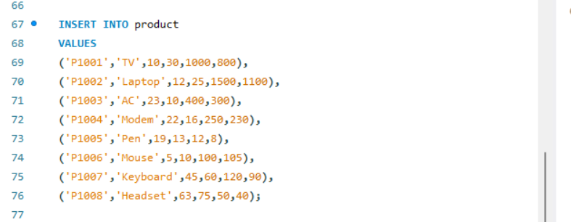
- Salesman
Salesman _Number | Salesman _Name | Address | City | Pincode | Province | Salary | Sales_Target | Target_Achieve | Phone
S001 | Huu | Phu Tan | Ho Chi Minh | 700002 | Ho Chi Minh | 15000 | 50 | 35 | 0902361123
S002 | Phat | Tan An | Hanoi | 700005 | Hanoi | 25000 | 100 | 110 | 0903216542
S003 | Khoa | Phu Hoa | Thu Dau Mot | 700051 | Binh Duong | 17500 | 40 | 30 | 0904589632
S004 | Tien | Phu Hoa | Dai An | 700023 | Binh Duong | 16500 | 70 | 72 | 0908654723
S005 | Deb | Hoa Phu | Thu Dau Mot | 700051 | Binh Duong | 13500 | 60 | 48 | 0903213659
S006 | Tin | Chanh My | Da Lat | 700032 | Lam Dong | 20000 | 80 | 55 | 0907853497
Script to insert data:
('S001','Huu','Phu Tan','Ho Chi Minh',700002,'Ho Chi Minh',15000,50,35,'0902361123'),
('S002','Phat','Tan An','Hanoi',700005,'Hanoi',25000,100,110,'0903216542'),
('S003','Khoa','Phu Hoa','Thu Dau Mot',700051,'Binh Duong',17500,40,30,'0904589632'),
('S004','Tien','Phu Hoa','Dai An',700023,'Binh Duong',16500,70,72,'0908654723'),
('S005','Deb','Hoa Phu','Thu Dau Mot',700051,'Binh Duong',13500,60,48,'0903213659'),
('S006','Tin','Chanh My','Da Lat',700032,'Lam Dong',20000,80,55,'0907853497');

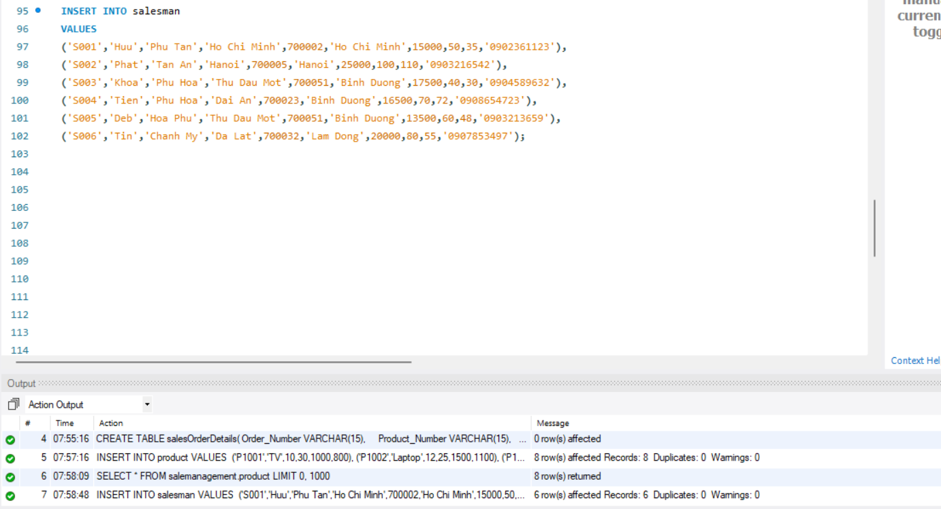

- Sales_order
Order_Number | Order_Date | Client_Number | Salesman_Number | Delivery_Status | Delivery_Date | Order_Status
O20001 | 2022-01-15 | C101 | S003 | Delivered | 2022-02-10 | Successful
O20002 | 2022-01-25 | C102 | S003 | Delivered | 2022-02-15 | Cancelled
O20003 | 2022-01-31 | C103 | S002 | Delivered | 2022-04-03 | Successful
O20004 | 2022-02-10 | C104 | S003 | Delivered | 2022-04-23 | Successful
O20005 | 2022-02-18 | C101 | S003 | On Way | null | Cancelled
O20006 | 2022-02-22 | C105 | S005 | Ready to Ship | null | In Process
O20007 | 2022-04-03 | C106 | S001 | Delivered | 2022-05-08 | Successful
O20008 | 2022-04-16 | C102 | S006 | Ready to Ship | null | In Process
O20009 | 2022-04-24 | C101 | S004 | On Way | null | Successful
O20010 | 2022-04-29 | C106 | S006 | Delivered | 2022-05-08 | Successful
O20011 | 2022-05-08 | C107 | S005 | Ready to Ship | null | Cancelled
O20012 | 2022-05-12 | C108 | S004 | On Way | null | Successful
O20013 | 2022-05-16 | C109 | S001 | Ready to Ship | null | In Process
O20014 | 2022-05-16 | C110 | S001 | On Way | null | Successful
Script to insert data:
('O20001','2022-01-15','C101','S003','Delivered','2022-02-10','Successful'),
('O20002','2022-01-25','C102','S003','Delivered','2022-02-15','Cancelled'),
('O20003','2022-01-31','C103','S002','Delivered','2022-04-03','Successful'),
('O20004','2022-02-10','C104','S003','Delivered','2022-04-23','Successful'),
('O20005','2022-02-18','C101','S003','On Way',null,'Cancelled'),
('O20006','2022-02-22','C105','S005','Ready to Ship',null,'In Process'),
('O20007','2022-04-03','C106','S001','Delivered','2022-05-08','Successful'),
('O20008','2022-04-16','C102','S006','Ready to Ship',null,'In Process'),
('O20009','2022-04-24','C101','S004','On Way',null,'Successful'),
('O20010','2022-04-29','C106','S006','Delivered','2022-05-08','Successful'),
('O20011','2022-05-08','C107','S005','Ready to Ship',null,'Cancelled'),
('O20012','2022-05-12','C108','S004','On Way',null,'Successful'),
('O20013','2022-05-16','C109','S001','Ready to Ship',null,'In Process'),
('O20014','2022-05-16','C110','S001','On Way',null,'Successful');
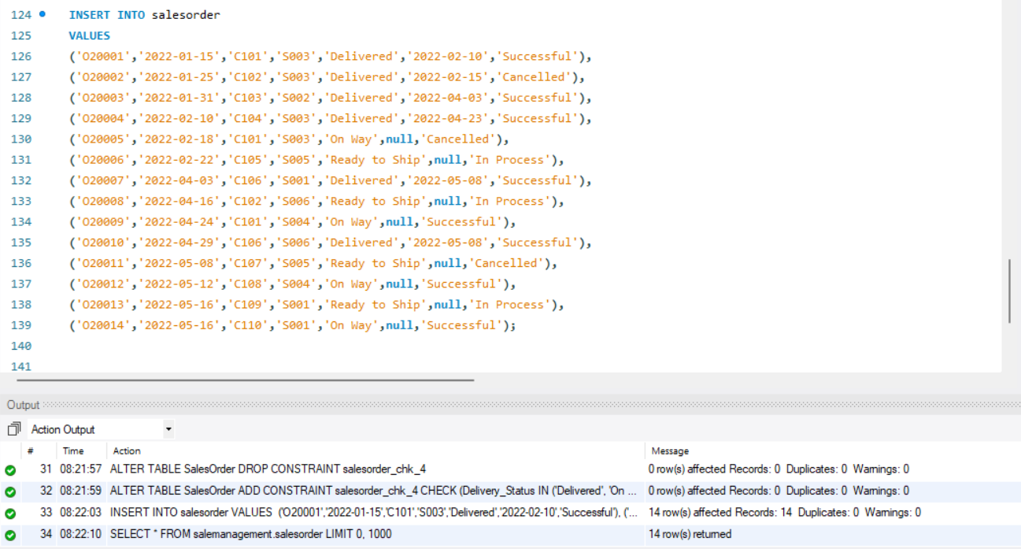
- Sales_Order_Details
Order_Number | Product_Number | Order_Quantity | Script to insert data:  ('O20001','P1001',5),  ('O20001','P1002',4),  ('O20002','P1007',10),  ('O20003','P1003',12),  ('O20004','P1004',3),  ('O20005','P1001',8),  ('O20005','P1008',15),  ('O20005','P1002',14),  ('O20006','P1002',5),  ('O20007','P1005',6),  ('O20008','P1004',8),  ('O20009','P1008',2),  ('O20010','P1006',11),  ('O20010','P1001',9),  ('O20011','P1007',6),  ('O20012','P1005',3),  ('O20012','P1001',2),  ('O20013','P1006',10),  ('O20014','P1002',20);
O20001 | P1001 | 5
O20001 | P1002 | 4
O20002 | P1007 | 10
O20003 | P1003 | 12
O20004 | P1004 | 3
O20005 | P1001 | 8
O20005 | P1008 | 15
O20005 | P1002 | 14
O20006 | P1002 | 5
O20007 | P1005 | 6
O20008 | P1004 | 8
O20009 | P1008 | 2
O20010 | P1006 | 11
O20010 | P1001 | 9
O20011 | P1007 | 6
O20012 | P1005 | 3
O20012 | P1001 | 2
O20013 | P1006 | 10
O20014 | P1002 | 20

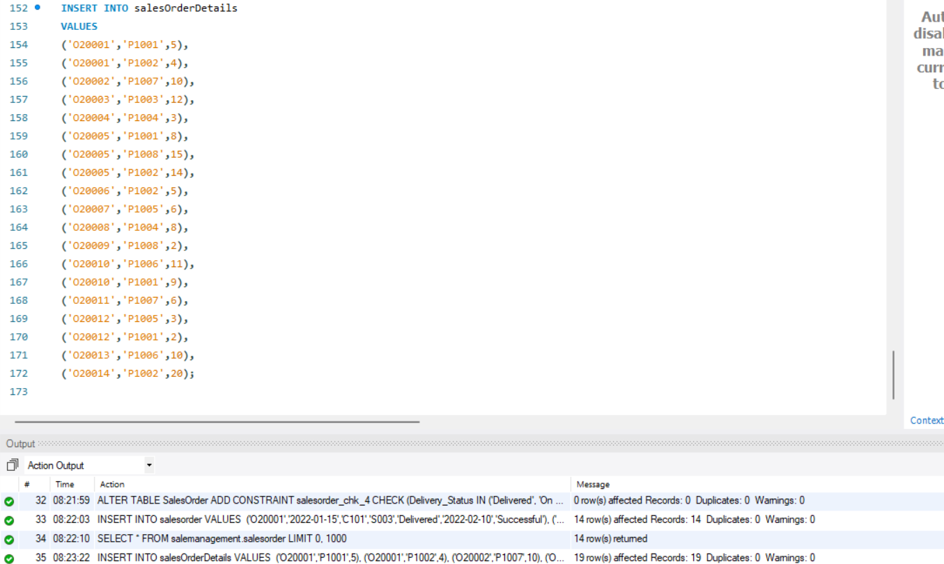
- Write SQL queries for following operations:
  - Show the schema of “Clients”, “Product”, “Salesman”, “Salesorder”, “Salesorderdetails” tables.
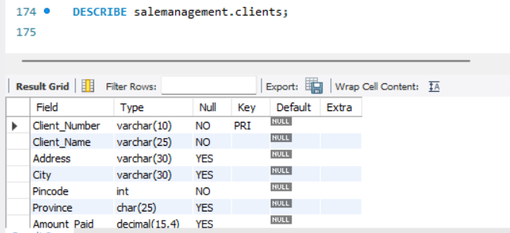
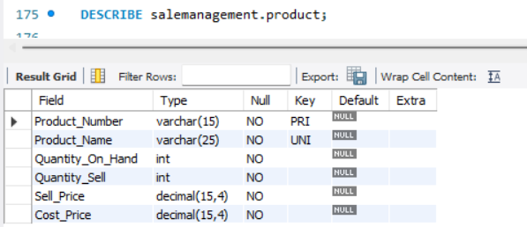
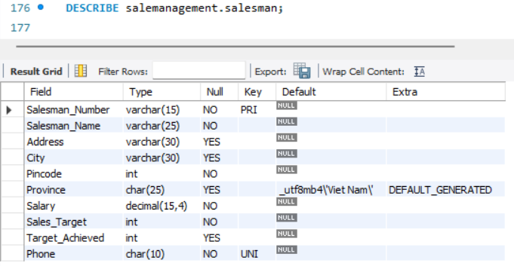
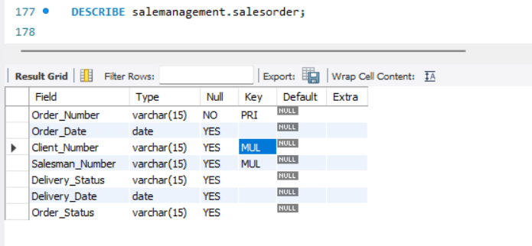
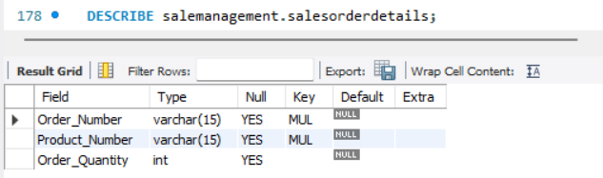
  - Display the content of “Clients”, “Product”, “Salesman”, “Salesorder”, “Salesorderdetails” tables.
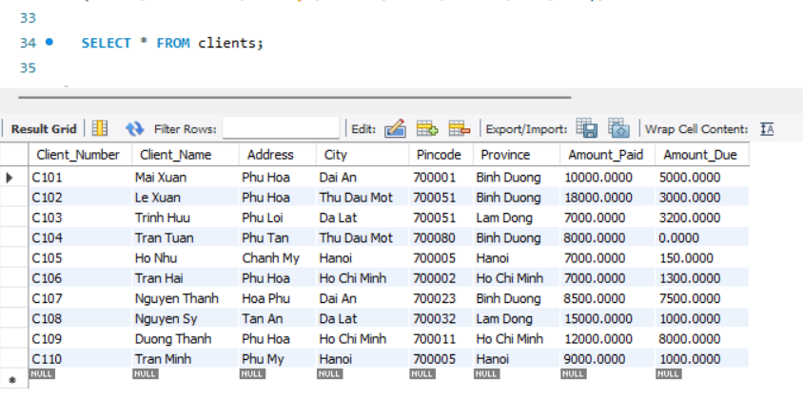
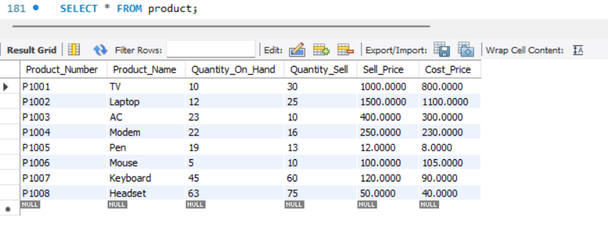
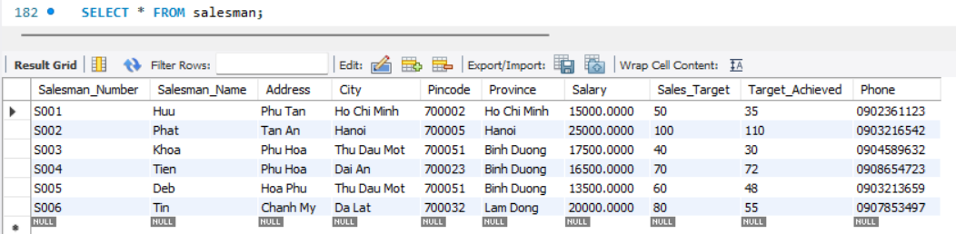
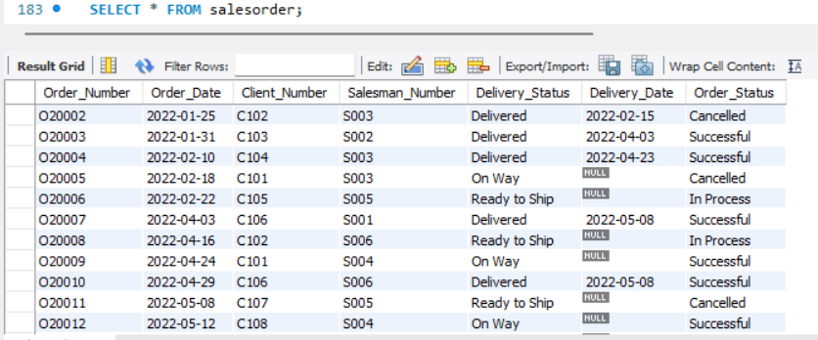
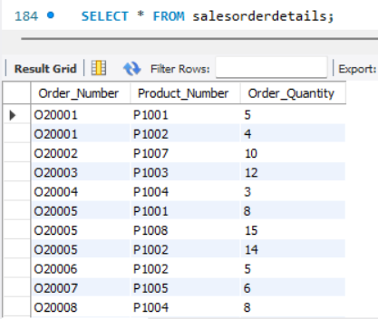

Problem 2: Human Resources Management Database
- Give the Database Schema below:
EMPLOYEES (employeeID, lastName, middle Name, firstName, date0fBirth, gender, salary, address, managerID, departmentID, IsManager)
DEPARTMENT (departmentID, departmentName, managerID, date0fEmployment)
DEPARTMENTADDRESS (departmentID, address)
PROJECTS (projectID, projectName, projectAddress, departmentID)
ASSIGNMENT (employeeID, projectID, workingHour)
RELATIVE ( employeeID, relativeName, gender, date0fBirth, relationship)
- Explaining datatype of attributes in the table:
EMPLOYEES (employeeID, lastName, firstName, middle Name, date0fBirth, gender, salary, managerID, departmentID)
# | Attribute | Datatype | Contraints
1 | employeeID | varchar(3) | PRIMARY KEY
2 | lastName | varchar(20) | NOT NULL
3 | middle Name | varchar(20) | NULL
4 | firstName | varchar(20) | NOT NULL
5 | date0fBirth | date - format MM-DD- YYYY | NOT NULL
6 | gender | varchar(5) | NOT NULL
7 | salary | money | NOT NULL
8 | address | varchar(100) | NOT NULL
9 | managerID | varchar(3) | FORIEGN KEY
10 | departmentID | int | FORIEGN KEY

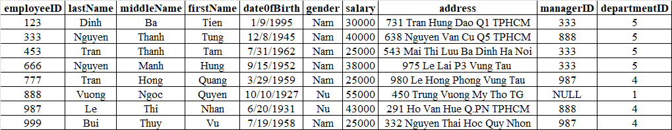
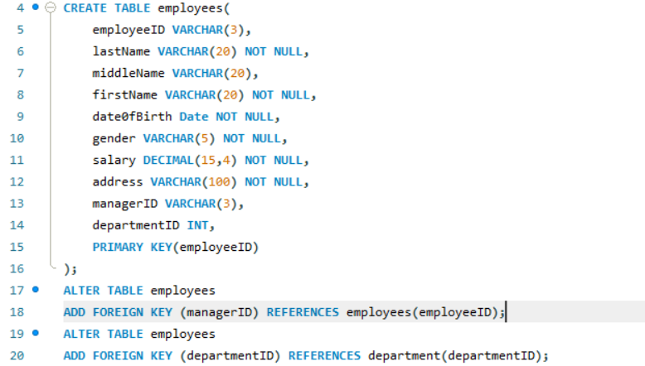

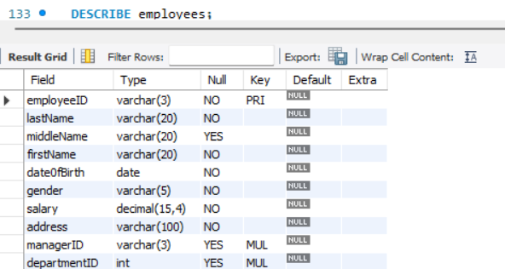
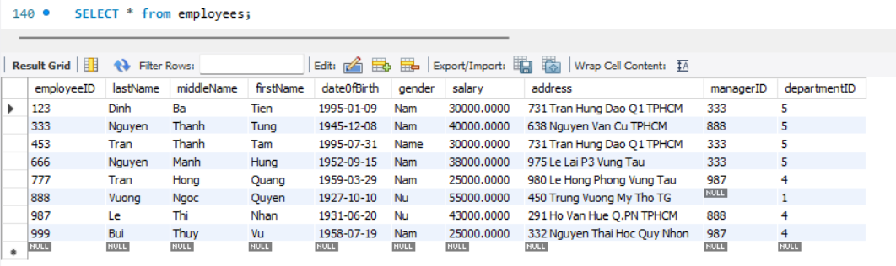
DEPARTMENT (departmentID, departmentName, managerID, date0fEmployment)
# | Attribute | Datatype | Contraints
1 | departmentID | int | PRIMARY KEY
2 | departmentName | varchar(10) | NOT NULL
3 | managerID | varchar(3) | FORIEGN KEY
4 | date0fEmployment | date | NOT NULL

departmentID | departmentName | managerID | date0fEmployment
1 | Quan ly | 888 | 19/06/1971
4 | Dieu hanh | 987 | 01/01/1985
5 | Nghien cuu | 333 | 22/05/1978

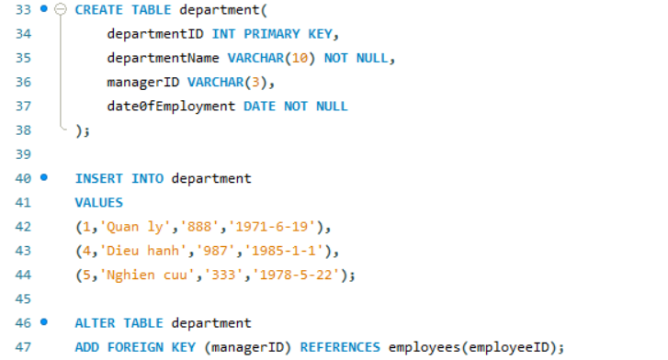
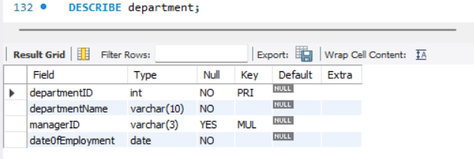
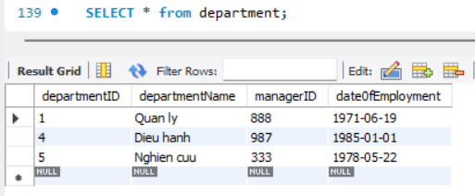
DEPARTMENTADDRESS (departmentID, address)
# | Attribute | Datatype | Contraints
1 | departmentID | int | PRIMARY KEY, FORIEGN KEY
2 | address | varchar(30) | PRIMARY KEY

departmentID | address
1 | TP HCM
4 | HA NOI
5 | NHA TRANG
5 | TP HCM
5 | VUNG TAU
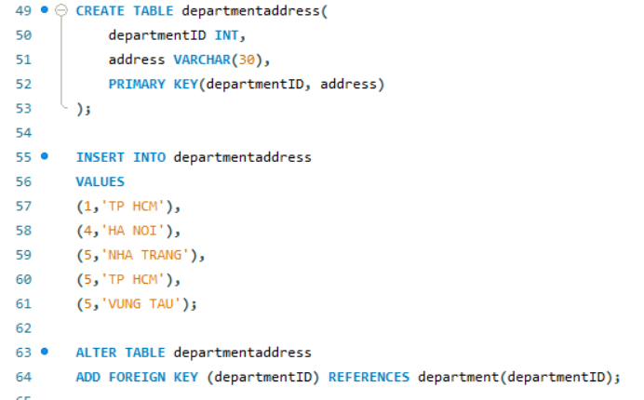
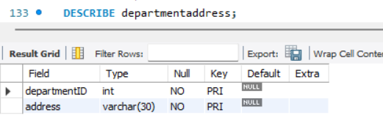
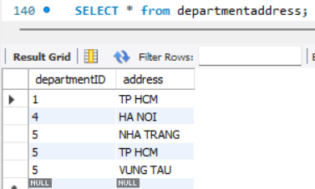
PROJECTS (projectID, projectName, projectAddress, departmentID)
# | Attribute | Datatype | Contraints
1 | projectID | int | PRIMARY KEY
2 | projectName | varchar(30) | NOT NULL
3 | projectAddress | varchar(100) | NOT NULL
4 | departmentID | int | FORIEGN KEY

projectID | projectName | projectAddress | departmentID
1 | San pham X | VUNG TAU | 5
2 | San pham Y | NHA TRANG | 5
3 | San pham Z | TP HCM | 5
10 | Tin hoc hoa | HA NOI | 4
20 | Cap Quang | TP HCM | 1
30 | Dao tao | HA NOI | 4

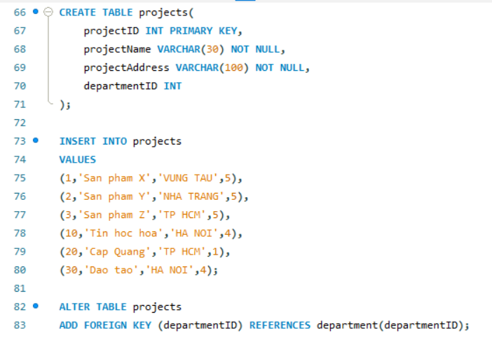
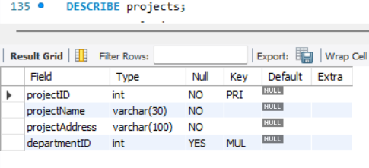
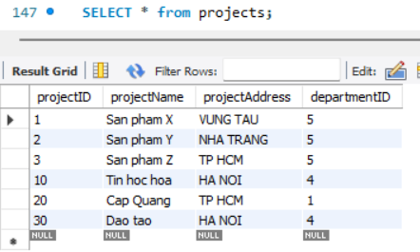
ASSIGNMENT (employeeID, projectID, workingHour)
# | Attribute | Datatype | Contraints
1 | employeeID | varchar(3) | PRIMARY KEY, FORIEGN KEY
2 | projectID | int | PRIMARY KEY, FORIEGN KEY
3 | workingHour | float | NOT NULL

employeeID | projectID | workingHour
123 | 1 | 22.5
123 | 2 | 7.5
123 | 3 | 10
333 | 10 | 10
333 | 20 | 10
453 | 1 | 20
453 | 2 | 20
666 | 3 | 40
888 | 20 | 0
987 | 20 | 15
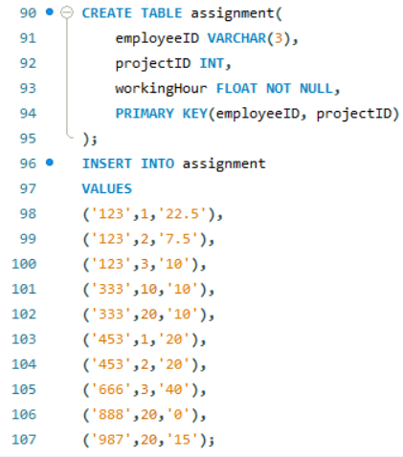
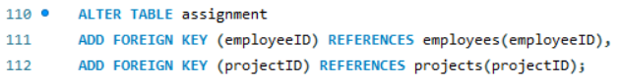
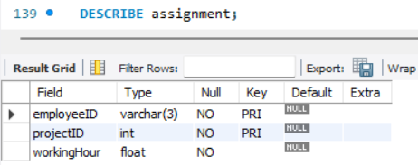
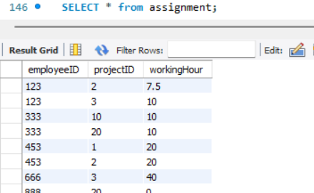
RELATIVE ( employeeID, relativeName, gender, date0fBirth, relationship)
# | Attribute | Datatype | Contraints
1 | employeeID | varchar(3) | PRIMARY KEY, FORIEGN KEY
2 | relativeName | varchar(50) | PRIMARY KEY
3 | gender | varchar(5) | NOT NULL
4 | date0fBirth | date | NULL
5 | relationship | varchar(30) | NOT NULL

employeeID | relativeName | gender | date0fBirth | relationship
123 | Chau | Nu | 12/31/1978 | Con gai
123 | Duy | Nam | 1/1/1978 | Con trai
123 | Phuong | Nu | 5/5/1957 | Vo chong
333 | Duong | Nu | 5/3/1948 | Vo chong
333 | Quang | Nu | 4/5/1976 | Con gai
333 | Tung | Nam | 10/25/1973 | Con trai
987 | Dang | Nam | 2/29/1932 | Vo chong
